Deer Mouse
Preferred habitat preferences:
- Prefers grasslands, forests, and shrubland
- Needs shelter to hide from predators
- Often lives near food sources like seeds and berries
Potential habitat home:
A small burrow under a log or inside a tree stump
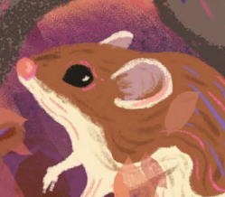
Acorn Woodpecker
Preferred habitat preferences:
- Likes oak woodlands and pine forests
- Needs trees with holes for nesting
- Prefers areas with plenty of acorns for food storage
Potential habitat home:
A tree with lots of holes for storing acorns and nesting
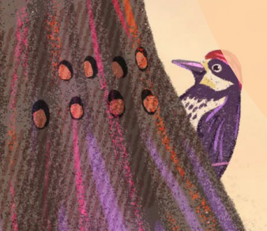
Western Screech Owl
Preferred habitat preferences:
- Prefers woodlands and deserts with tree cover
- Nests in tree cavities or abandoned woodpecker holes
- Hunts small mammals and insects at night
Potential habitat home:
A hollowed-out tree trunk or a nesting box
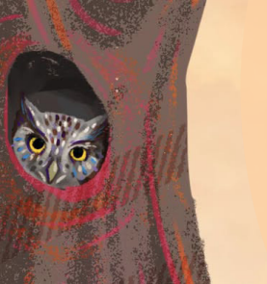

Gray Squirrel
Preferred habitat preferences:
- Lives in forests, parks, and urban areas with trees
- Needs trees for climbing and food like nuts and seeds
- Builds nests high off the ground for safety
Potential habitat home:
A leafy nest (called a drey) in the branches of a tall tree
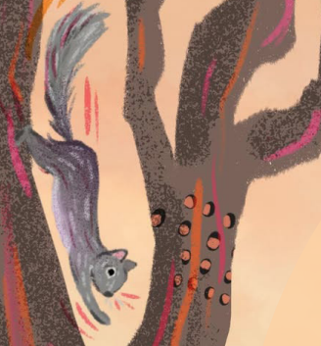
Porcupine
Preferred habitat preferences:
- Lives in forests, rocky areas, and near water
- Prefers trees or caves for shelter
- Needs places to hide during the day and come out at night
Potential habitat home:
A den in a rocky crevice or a hollow log
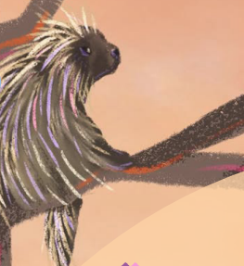
Choose or create your own animal!
Preferred habitat preferences:

Potential habitat home:

